

# Wuhan ICF System Release Notes

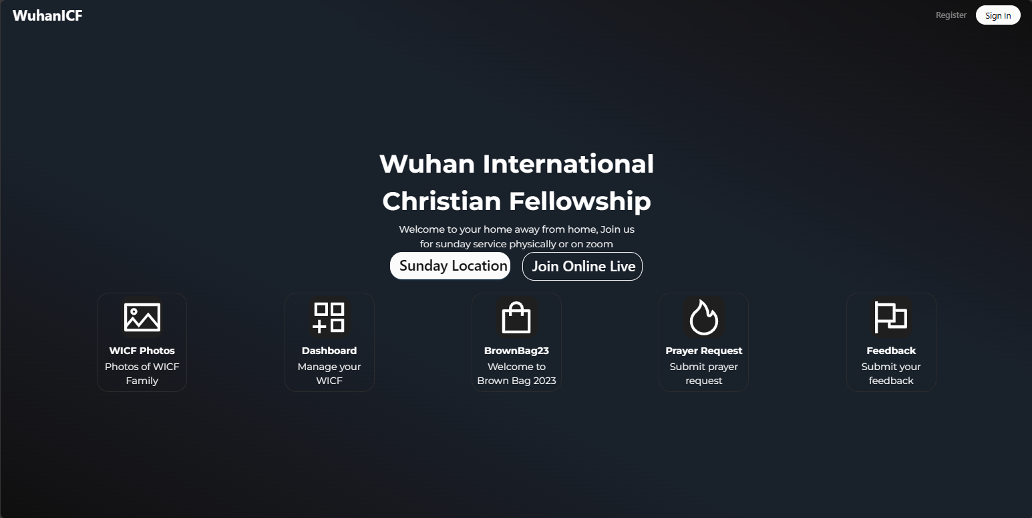

Last Updates: 2024.03.16  
By: Paul Ernest Kachule

**Contents**

Wuhan ICF System Release Notes 1

Update 240315 - User experience improvements 3

Image Optimization Options 3

"Back to Top" Button for WICF Photos 4

Custom User Profile Images 5

Update 240314 - Prayer Request Management 6

Prayer Request Submissions 6

Email Notifications 7

Prayer Assignments 7

Prayer Assignment Emails 8

Update 240310 – WICF Photos & Feedback 8

WICF Feedback 8

WICF Photos Albums 9

WICF Photos Downloads and sharing 9

Photo Album Management 10

Single Photo Management 11

Previously Established Features 12

Account Management 12

Sunday Location 14

Sunday Location Management 14

Sunday Live Streams 15

Sunday Live Stream Management 16

Leader Data Management and Export 17

Permission management 17

## Update 240315 - User experience improvements

Our church system now includes a series of improvements designed to enhance user experience, navigation and personalization.

### **Image Optimization Options**

Administrators now have the ability to selectively apply image optimization, preserving the quality of images with lower resolution when necessary.

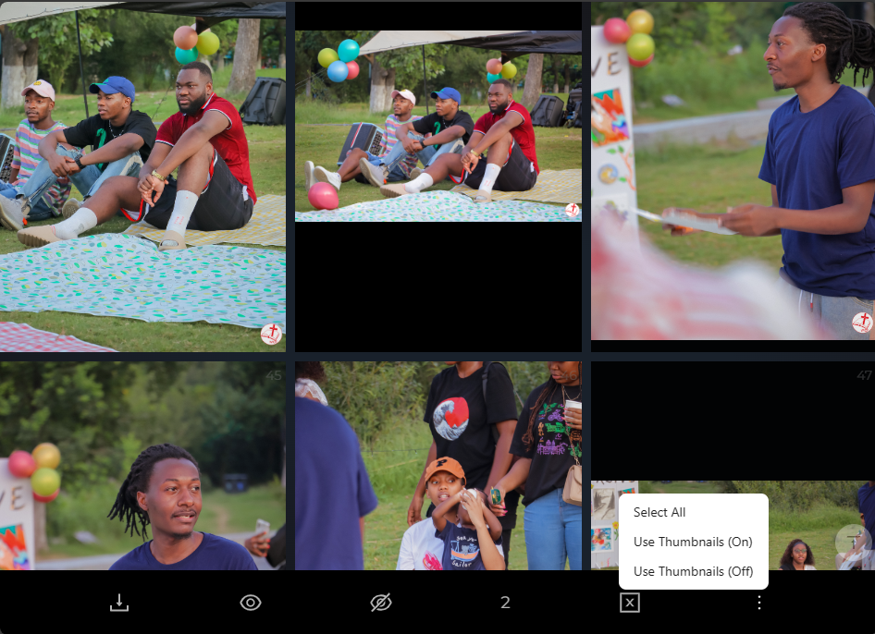

For images that look poor quality when using the optimized thumbnails, these new options allow the admin to opt out for the photo optimization:

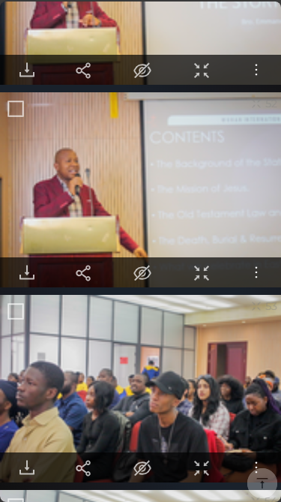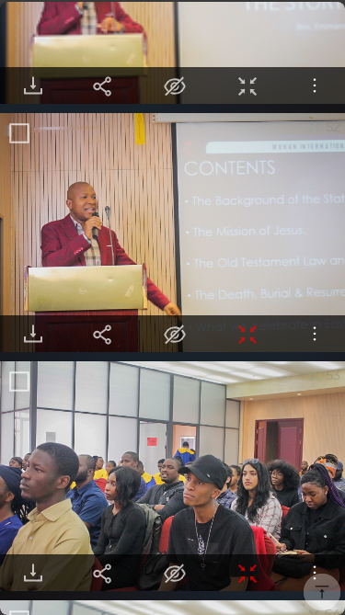

### **"Back to Top" Button for WICF Photos**

A new "Back to Top" button has been added across WICF photos sections.



### **Custom User Profile Images**

Users can now customize their profiles by setting a profile picture directly from WICF photos.

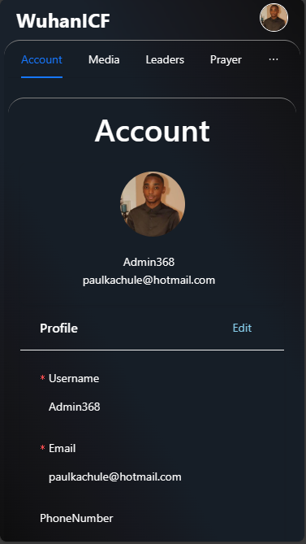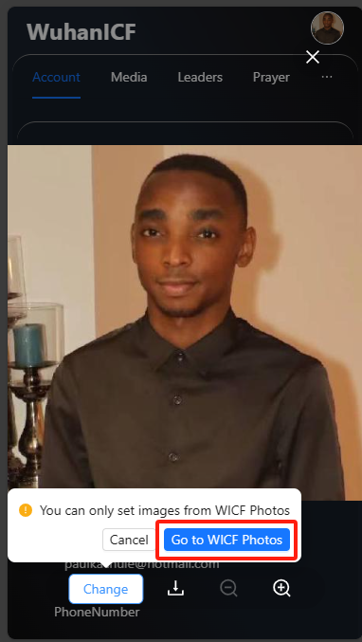  
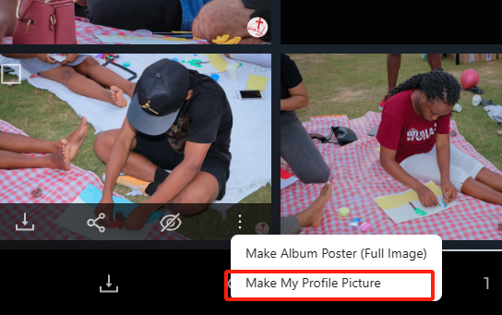

## Update 240314 - Prayer Request Management

Our church system has been updated with a new features : Prayer Request Management.

### **Prayer Request Submissions**

Members of the WICF can now easily submit prayer requests through the church system.  
  
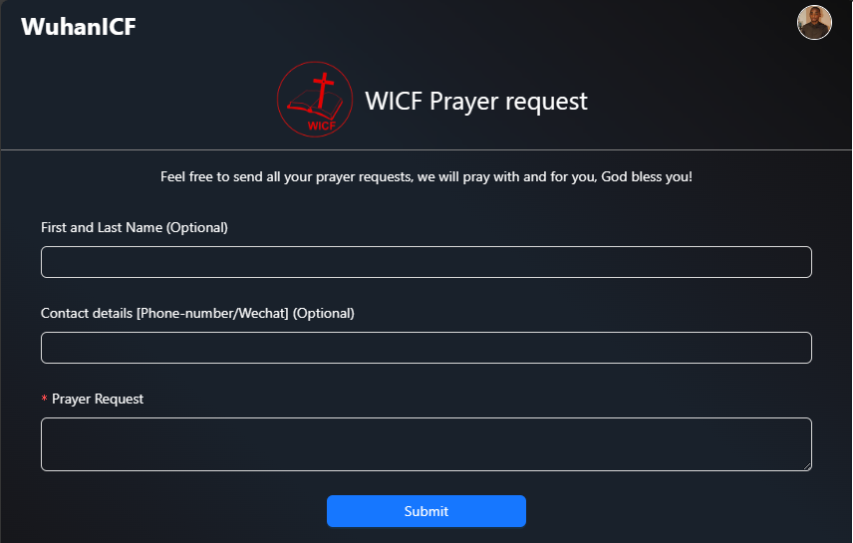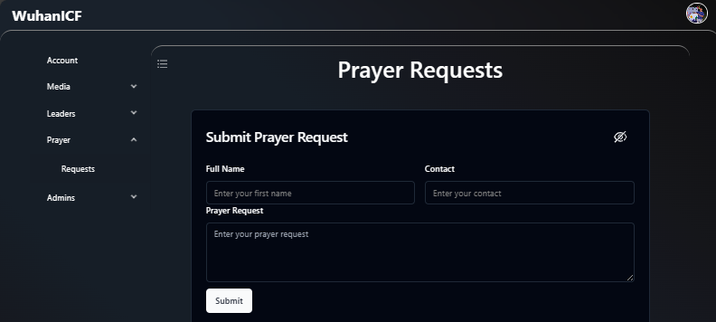

### **Email Notifications**

Members of the prayer ministry can now receive notifications when a new prayer request is submitted.  
  
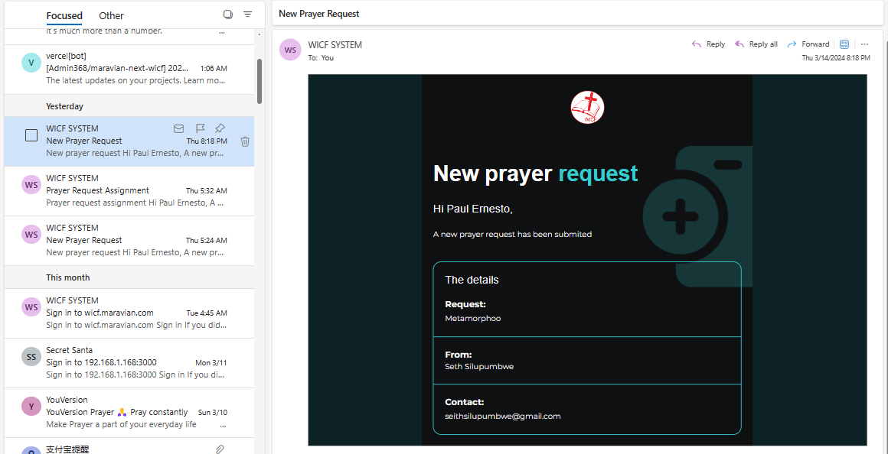

### **Prayer Assignments**

Assignments of specific prayer requests to a member of the prayer team for intercession has also been added.  
  
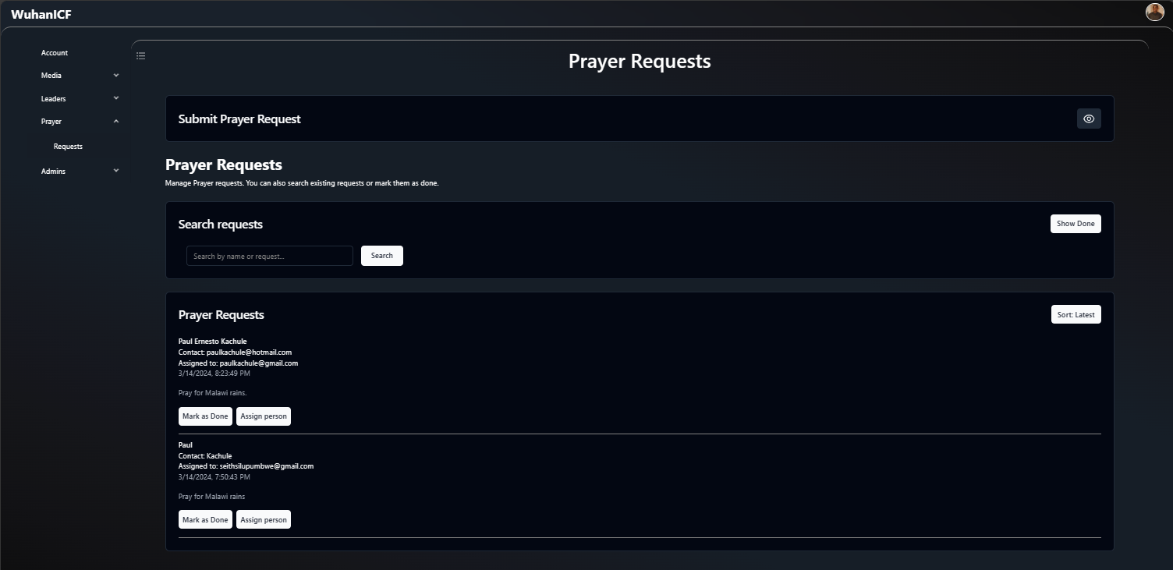

### **Prayer Assignment Emails**

Members receive notification when they have been assigned a prayer request.

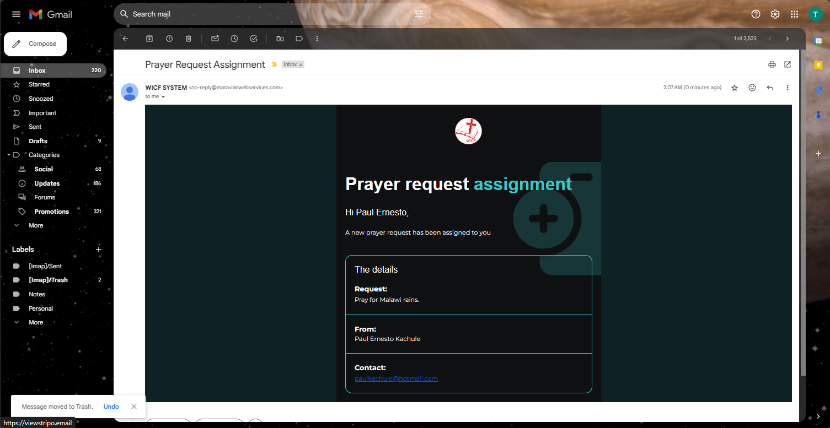

The inspiration for this update came from the growing need for efficient communication between church members and the prayer ministry. Additionally, it aims to streamline the process of managing and tracking prayer requests within our church community.

## Update 240310 – WICF Photos & Feedback

The church system has been updated with a new features:

### **WICF Feedback**

Introducing the WICF feedback section where members can submit their feedback  
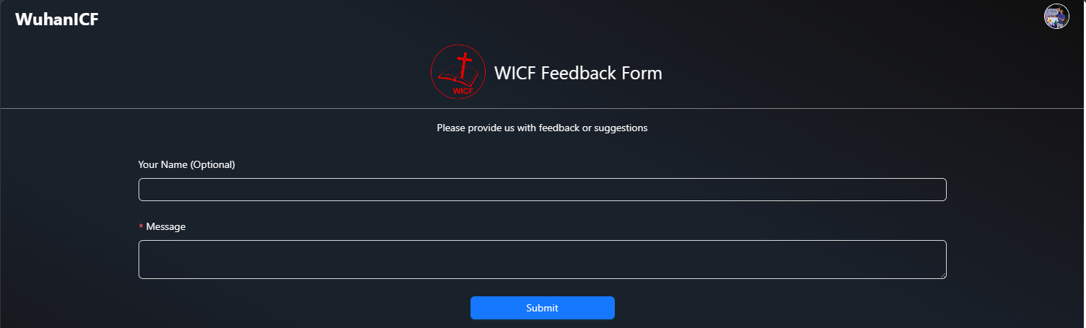

### **WICF Photos Albums**

Members can now access large amounts of photos from regular Sundays and special events that are too many to share on social media.

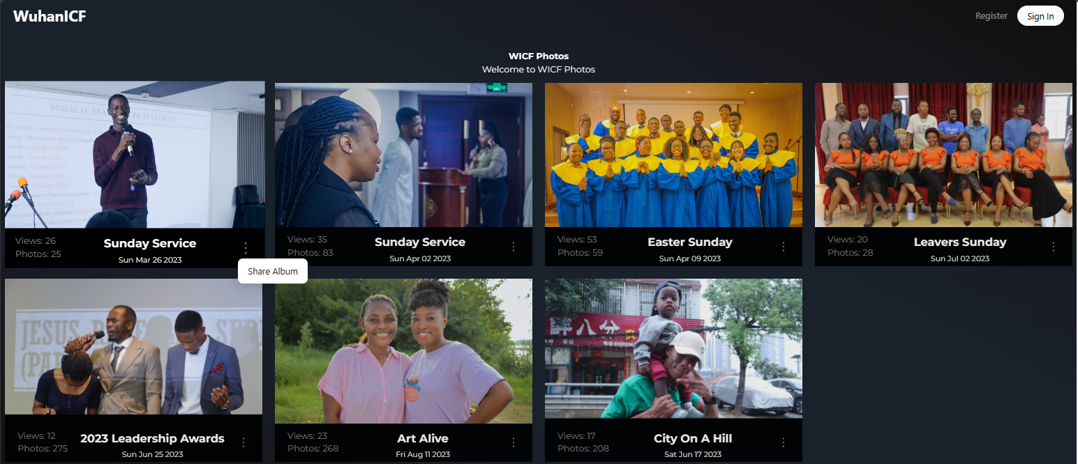

### **WICF Photos Downloads and sharing**

From any album, users can be able to share or download an optimized version of the photos or the full version of the images.

### **Photo Album Management**

Admins or media members have some management features:

- Update Image DB: which checks the images from the server and updates or adds albums if they are new ones.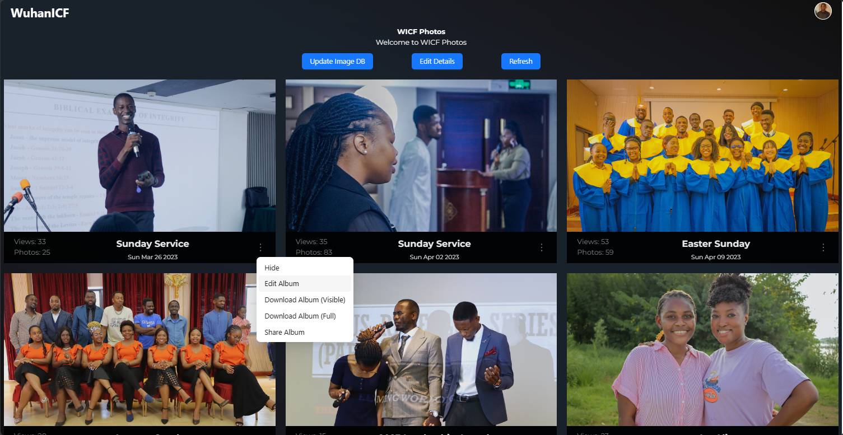

- Hide / Show albums

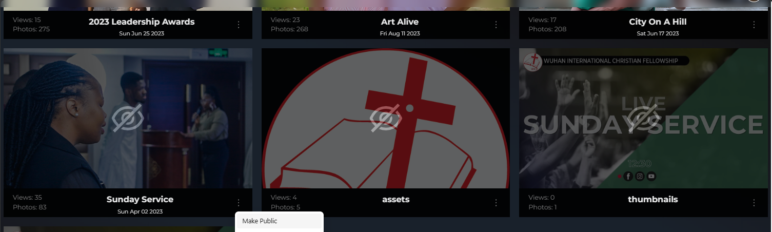

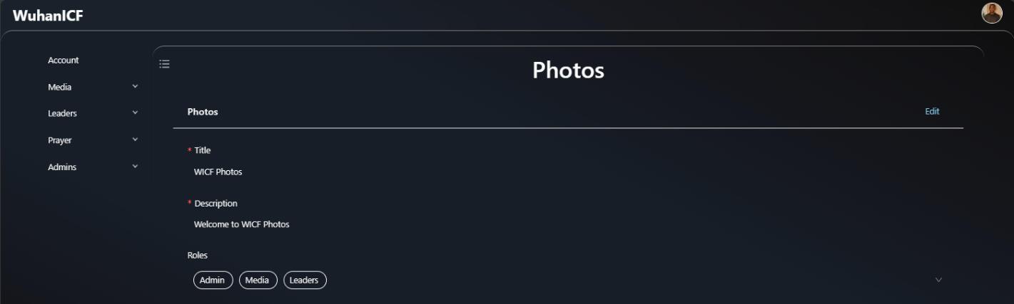- Edit the Photos Section Title, Description and roles which can be able to manage photos

- Edit photo album details and dates.

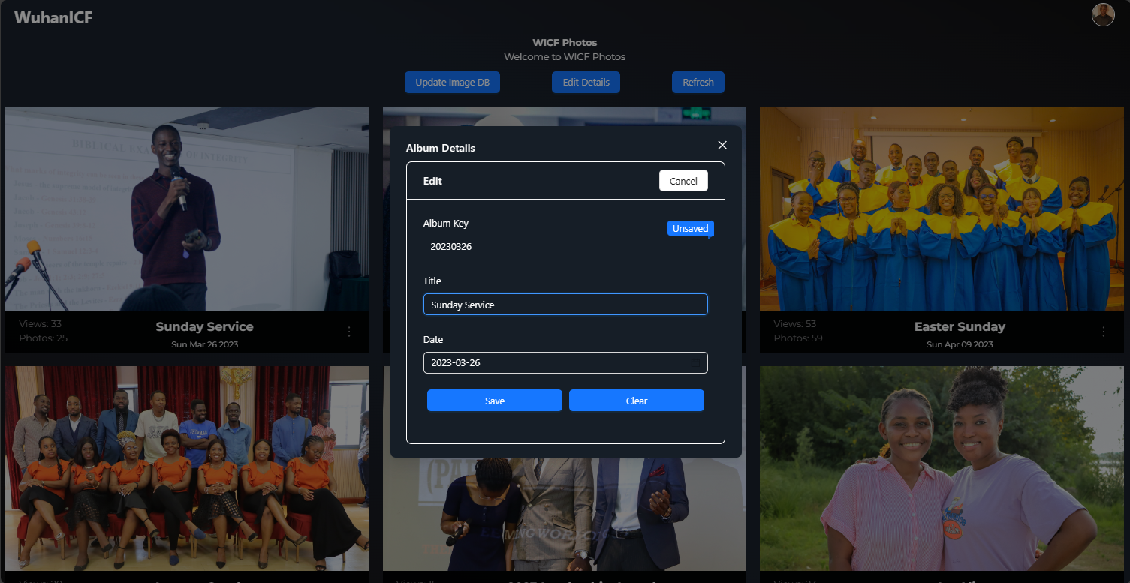

### **Single Photo Management**

There are also some features for managing single images in an album.

- Hide / Unhide images

- Change the poster for the album



**Previously Established Features**

Here are some previously established features of the Wuhan ICF System:

**Account Management**

Members can create and manage their accounts, update personal information, and change their password.

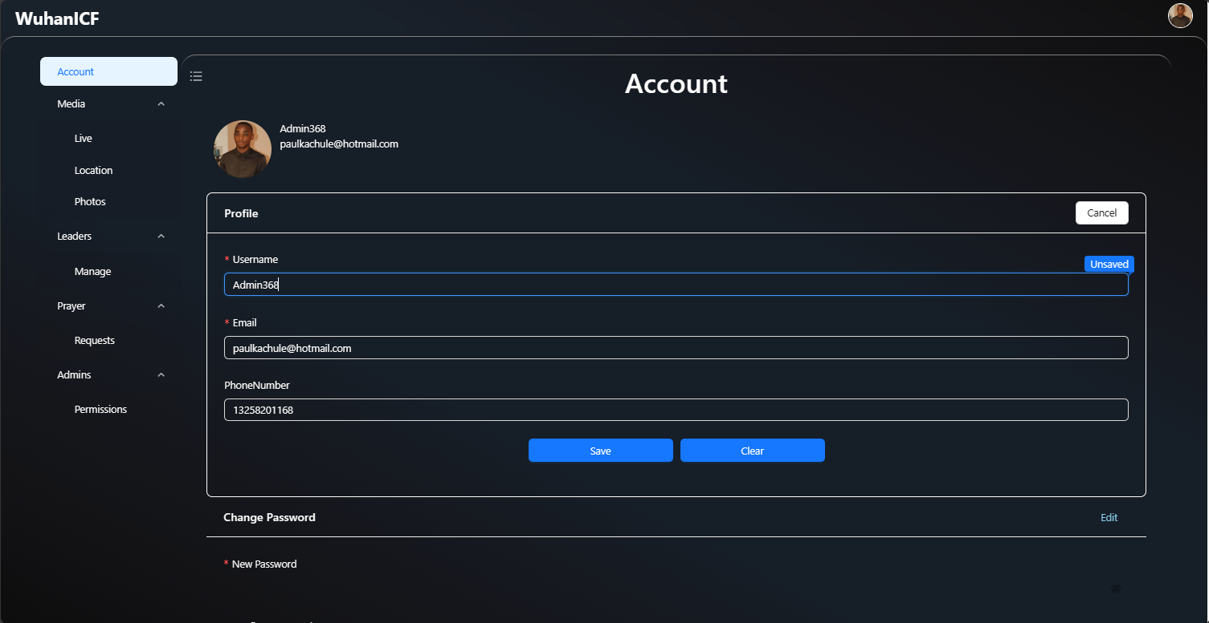

When a member makes an account, they can then join the WICF by filling the WICF membership information.  
  
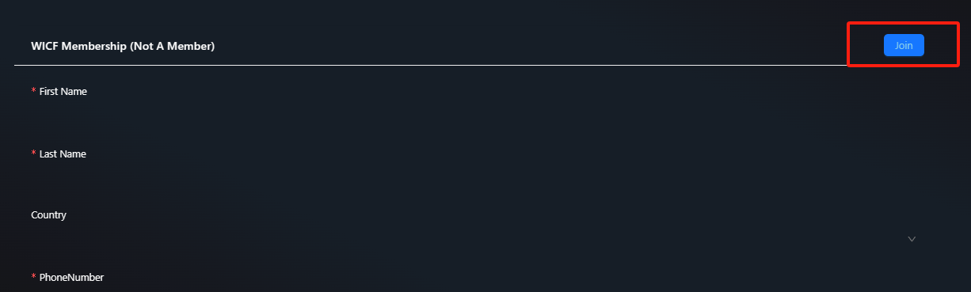

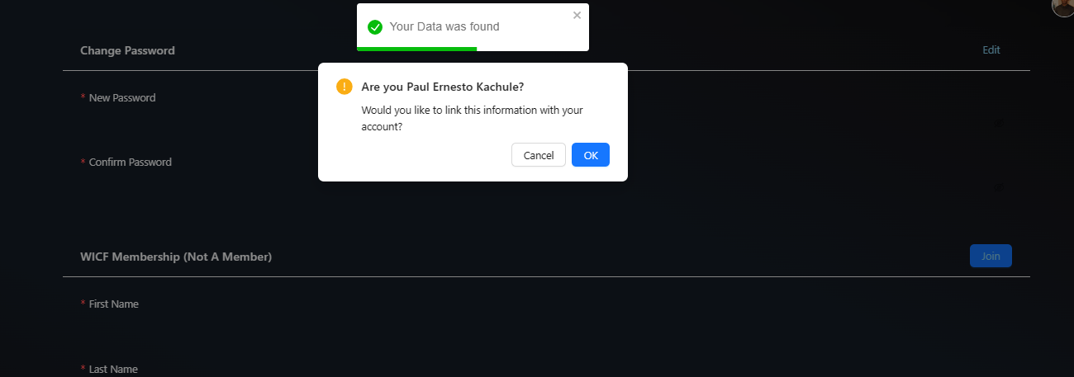If the Church already has information on the member it will ask you to verify if it is you and your information will be linked with your account

Then after saving you will be registered as an official WICF member.  
  
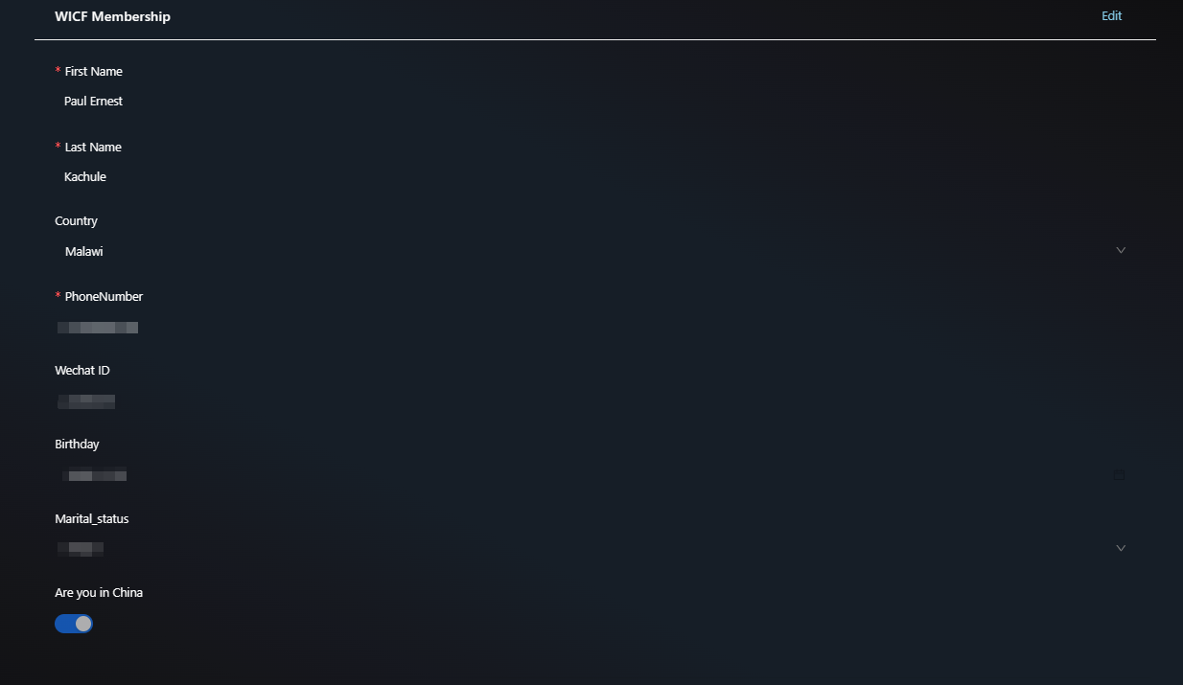

**Sunday Location**

Since our Sunday location changes, it is sometimes difficult to find where the new location is. We now have a permanent link where members can find the current church location that is only accessible to official registered WICF members for security reasons.



**Sunday Location Management**

Leaders and media members have the access to dynamically update and change the Sunday location so that the location link is updated.  
  
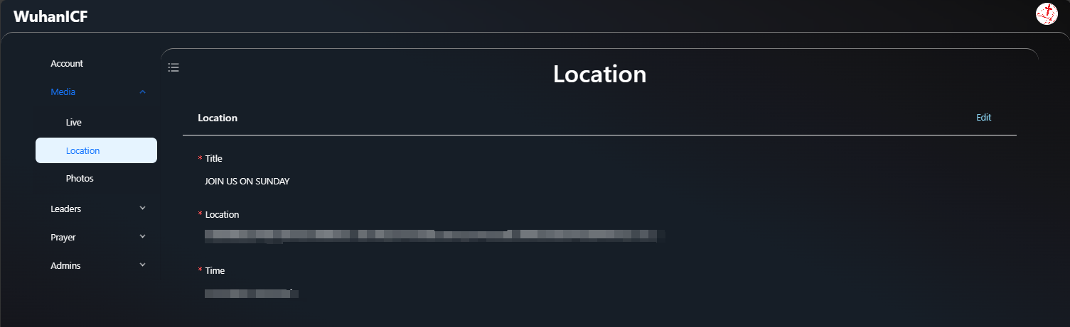

**Sunday Live Streams**

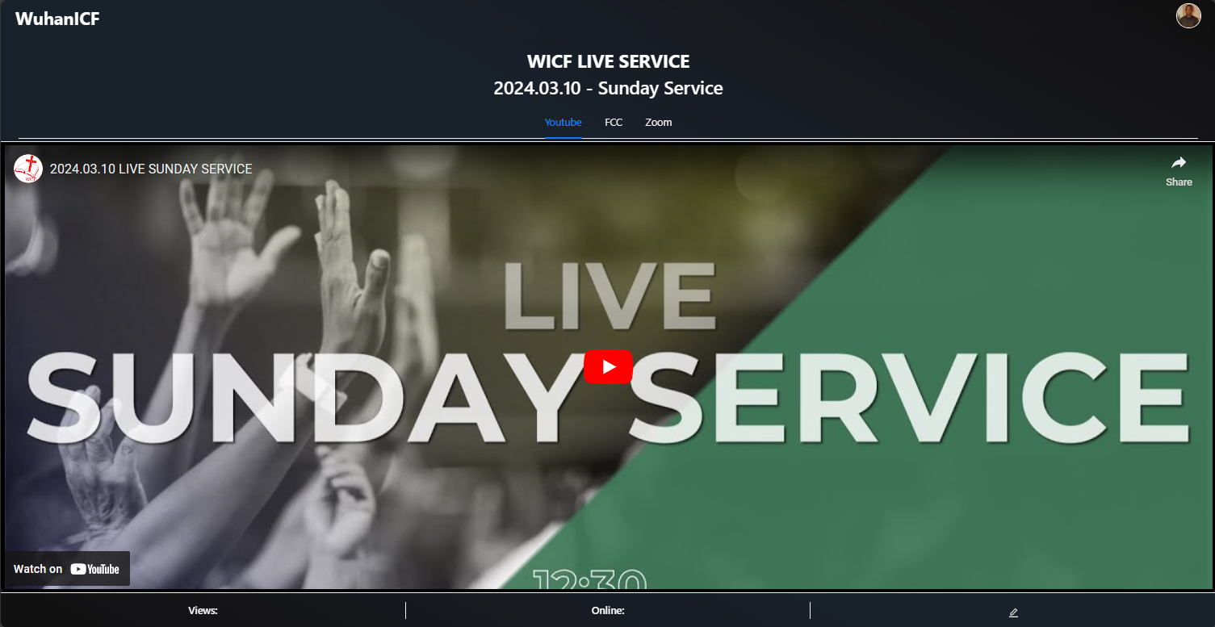Normally on a Sunday there is a live stream on either YouTube, FCC or zoom, and it becomes difficult for church members to know which links or codes are being used.

With the Wuhan ICF System, users can now easily access the live stream links and codes for Sunday services, ensuring they do not miss a Sunday service.

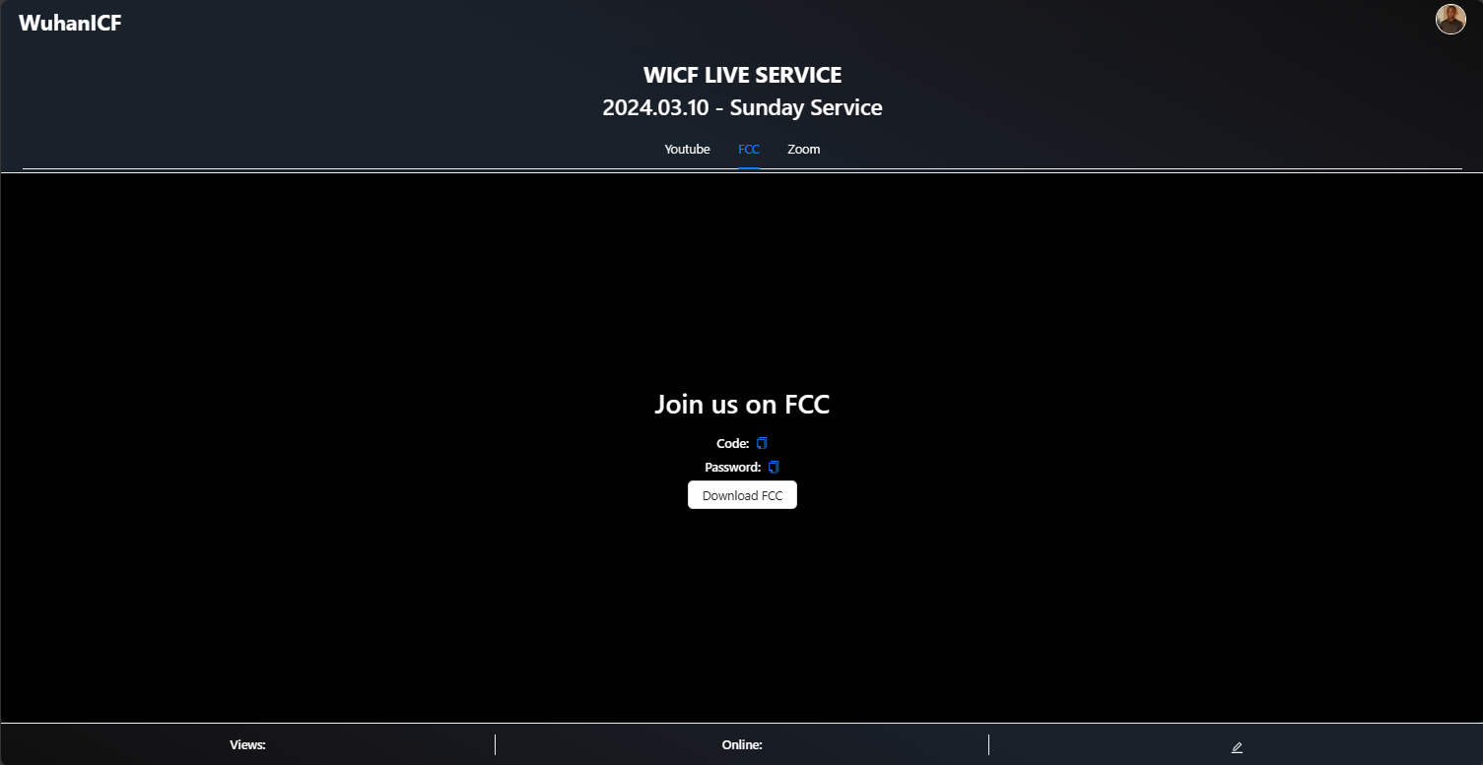

**Sunday Live Stream Management**

For the admins and media team, the church system now offers enhanced management capabilities for Sunday live streams.

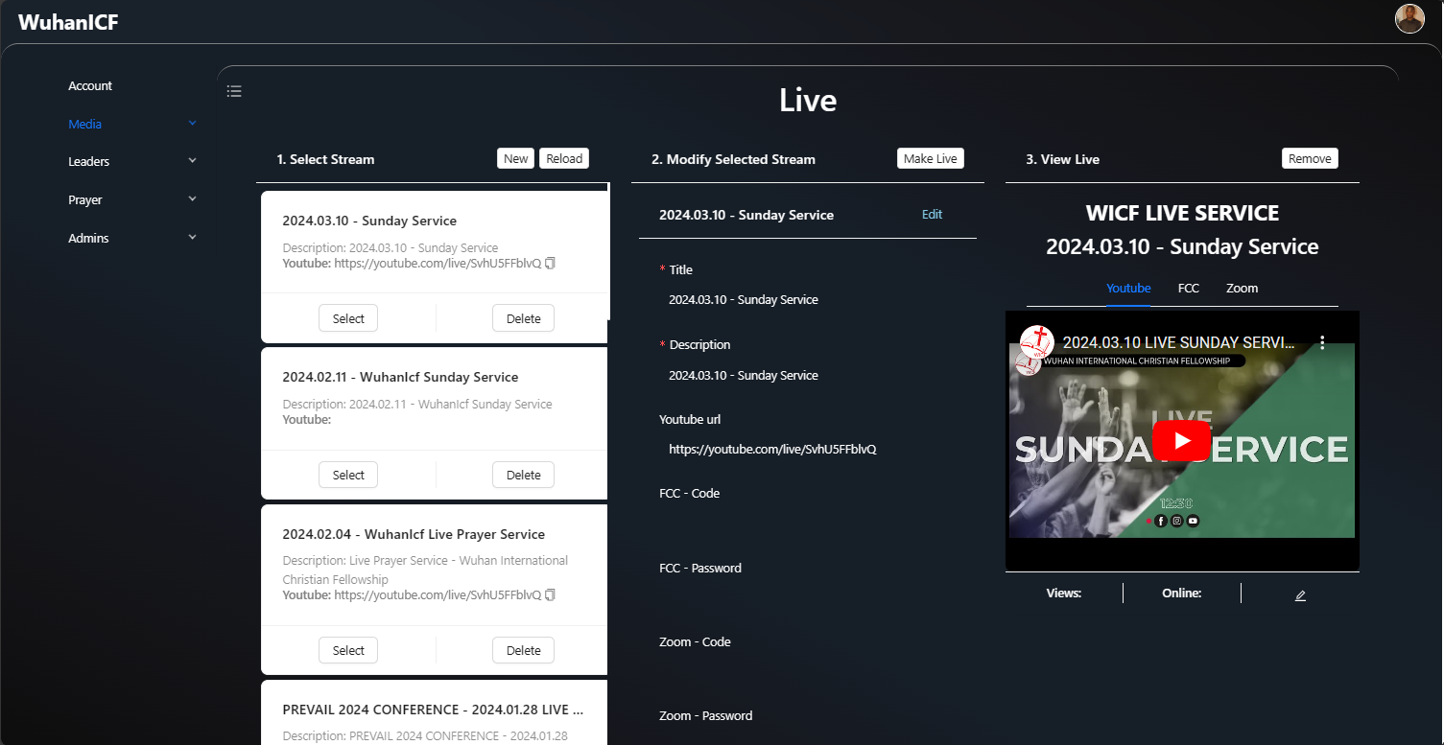

Admins and media team members can set, update, and manage the live stream, including adding descriptions, links, and meeting codes.  
  
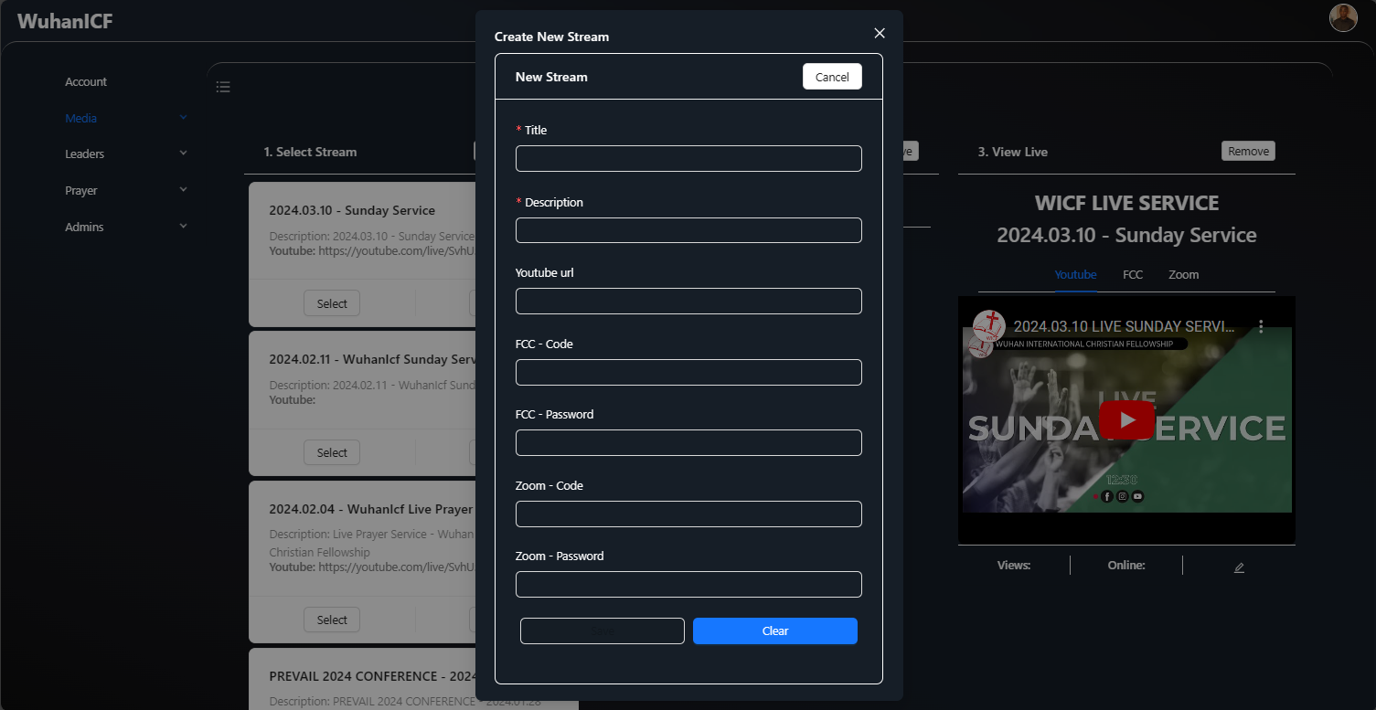

**Leader Data Management and Export**

The Wuhan ICF System now includes a feature for leaders to easily manage and export data related to their specific areas of responsibility within the church.  
  
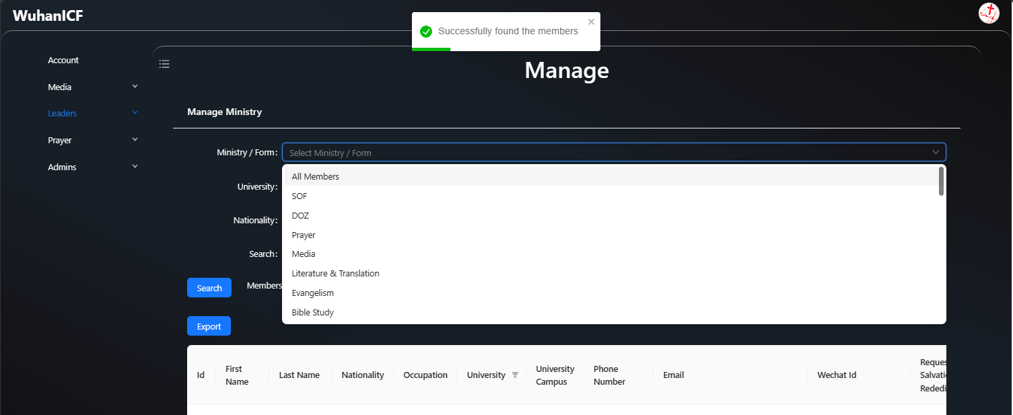

**Permission management**

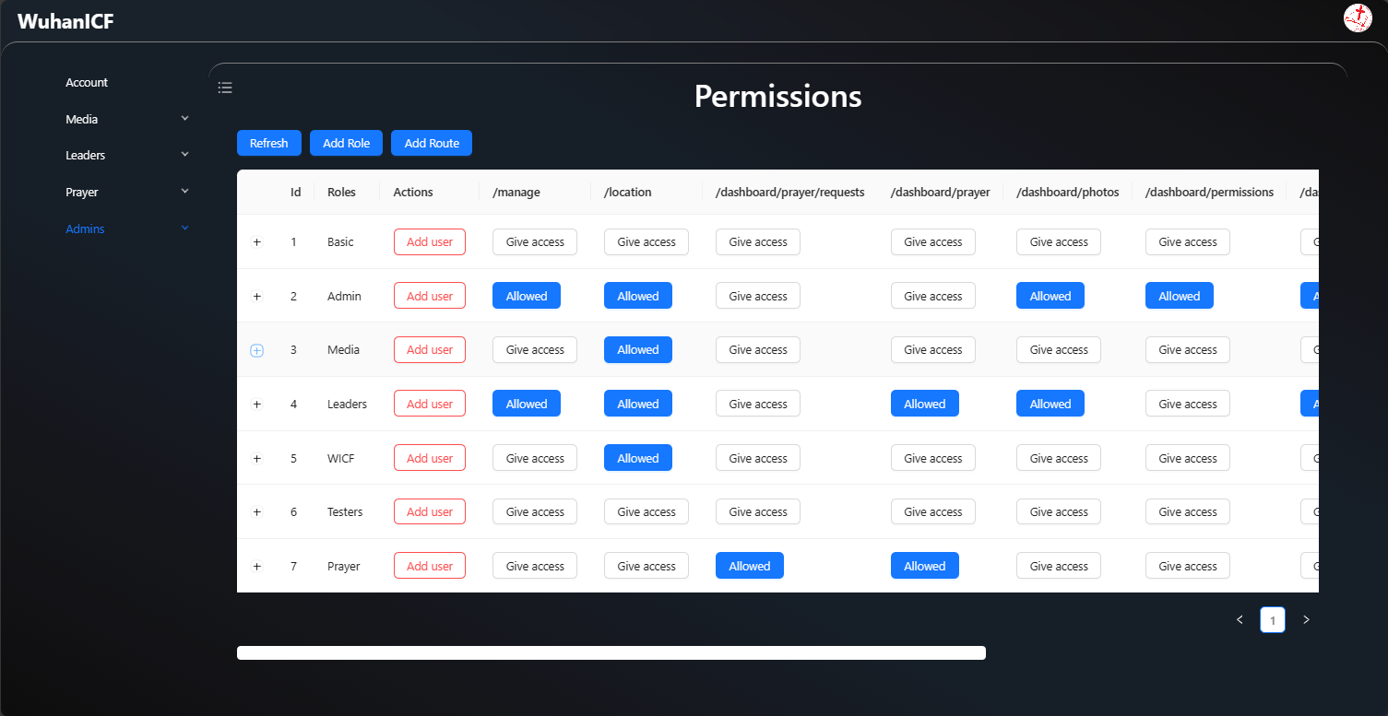The Wuhan ICF System now includes a permission management feature, allowing admins to grant specific access and permissions to different users within the system.

Admins should create the specific routes that require permissions, make the roles to assign those permissions, assign the routes to the specific roles and then assign the appropriate roles to users.